Go to the transaction SE24.

Enter the class name **CL_EXITHANDLER**. Click on Display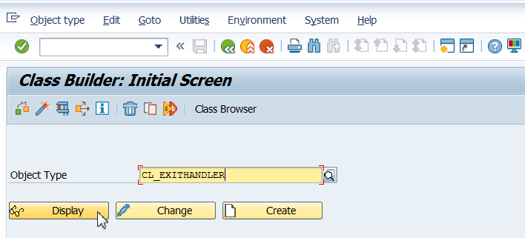

Double-click the method **GET_INSTANCE.**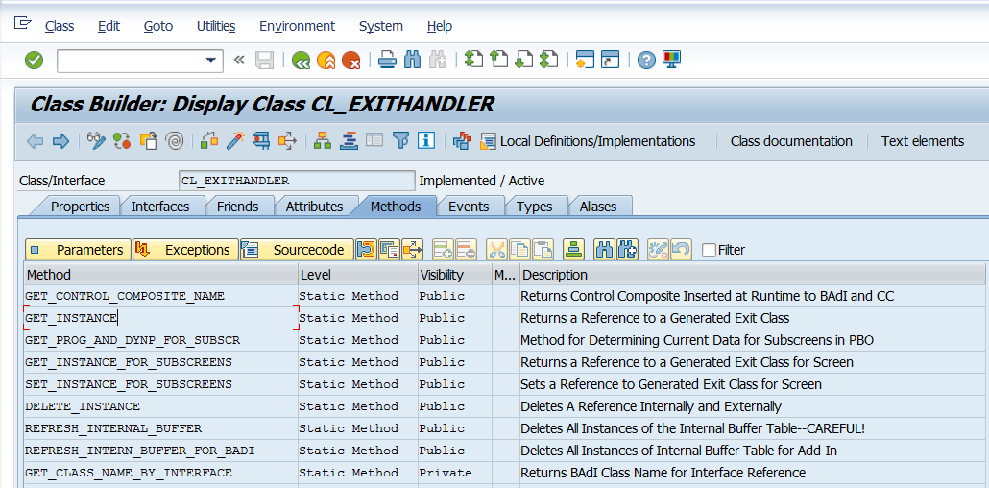

Set a breakpoint at command line CASE sy-subrc (line 25).

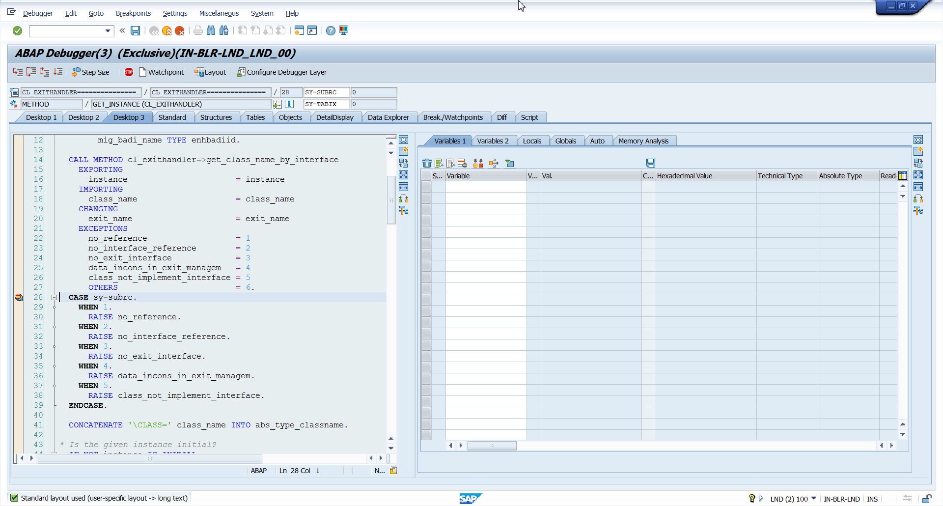

Execute the transaction that you want to analyze.  It will stop at the breakpoint you have just set on class **CL_EXITHANDLER** whenever it finds any BADI method/Exit call.

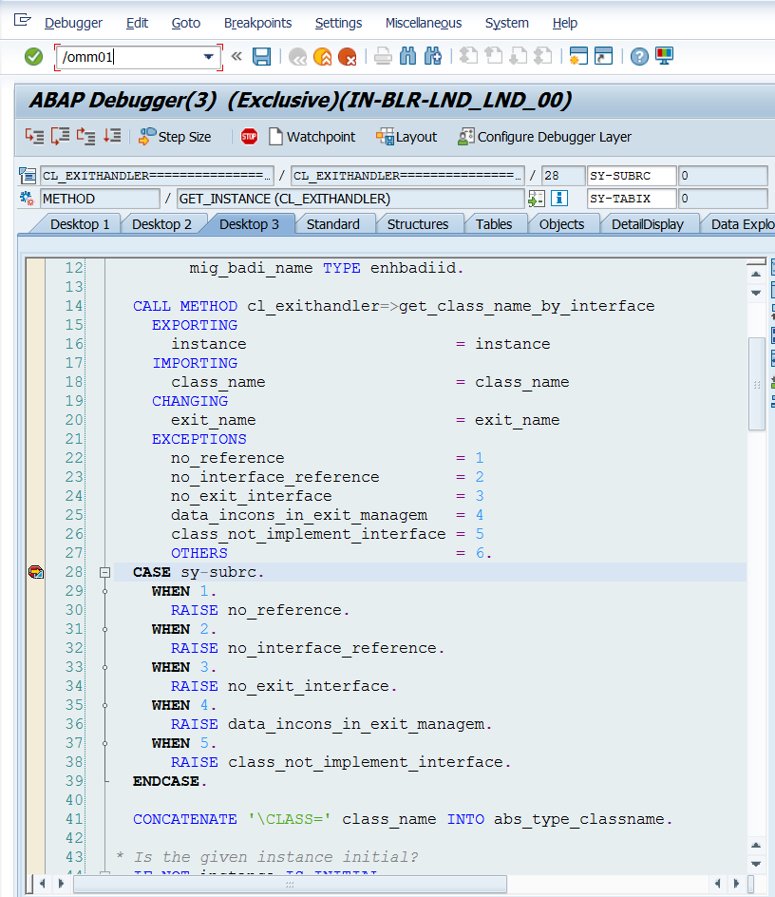

After executing the debugged code- click on exit name in line 20 and u can see the name of the exit – that shows it has BADI.

